YEAR 7 SCIENCE
LIFE AND LIVING
REVISION - ECOLOGY

1. You need to know what the following things are and how they fit into the ecosystem.
Write their meaning next to them.

• Habitat

• Biotic factors (List 3 examples.)

• Abiotic factors (List them.)

• Producer

• Consumer

• Decomposers

• Carnivore

• Herbivore

• Omnivore

• Food chains - what do the arrows mean? Which way do the arrows go?

• First order consumer

• Second order consumer

• Food web

• Energy flow in an ecosystem.

• The sun's role in food chains and food webs.

• Introduced species

• Endangered species

• Ecosystem

• Competitor in an ecosystem

• Biosphere

• Environment

• Community

2. Use the following food web to answer the associated questions.

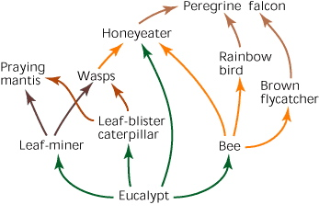
(a) Name a herbivore.

(b) Name two first-order consumers.

(c) Name a carnivore.

(d) Name two third-order consumers.

(e) Write down three different food chains containing the peregrine falcon.

•

•

•

(f) What do the arrows represent?

(g) If the leaf miner is wiped out by a virus, give two effects this would have on the food web.

•

•

3. Complete the table below by classifying the named component as biotic or abiotic.

Component | Biotic or abiotic? | Component | Biotic or abiotic?
Water salinity |  | Competitors for mating
Wind speed and direction |  | Producers
Competitors for food |  | Humidity
Predators |  | Decomposers
Light penetration |  | Air temperature

4. Look at the following diagram and answer the following questions.
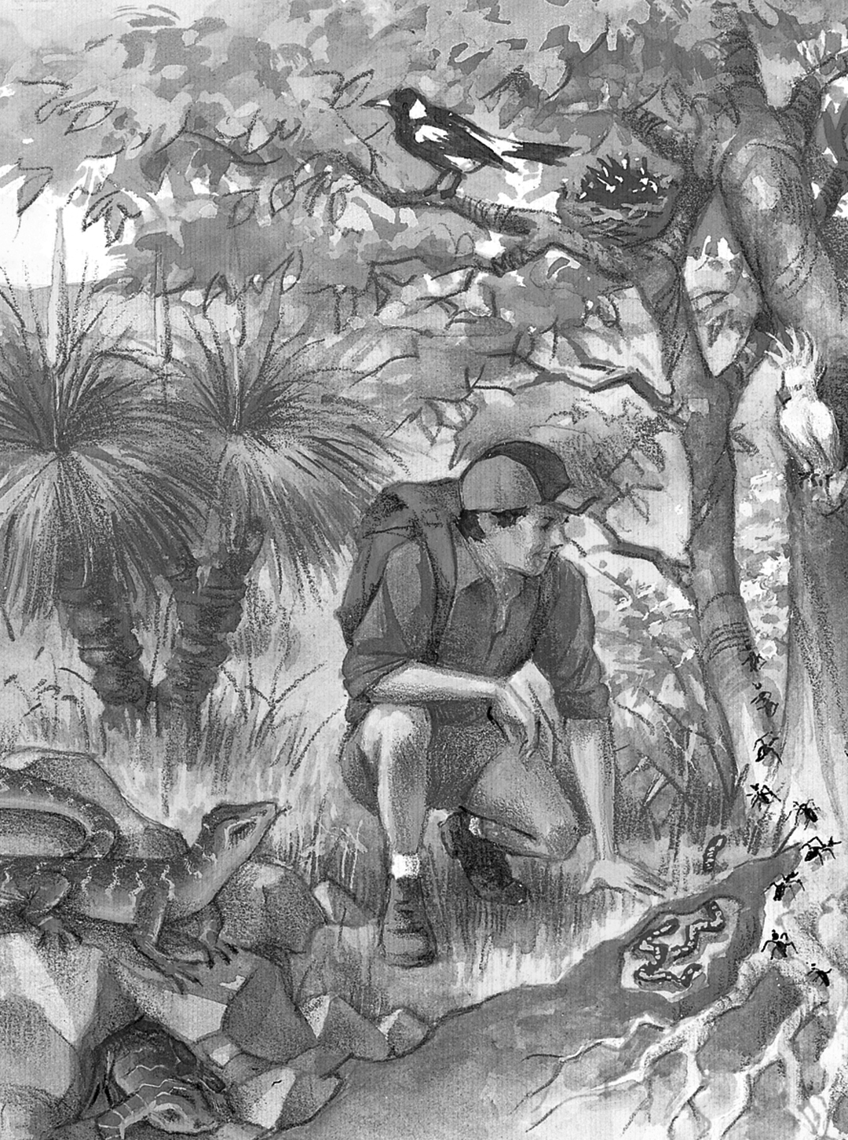
(a) Why are the trees and grass so important to this ecosystem?

(b) Why are earthworms so important in the soil under the tree?

5. An estuary is where a river meets the sea. Estuaries often contain shallow salty water in which a water grass called eel grass grows. The larva of small animals called copepods use the grass as a food source. Eels are predators of copepods and the eels are the prey of adult herring fish.

(a) Use this information to complete the food chain.

In this food chain, identify the:

(b) herbivore

(c) second order consumer

(d) producer.

6. (a) Use the following information to construct a food web on the following page.

• Frogs are eaten by snakes.
• Wombats eat grass.
• Magpies eat grasshoppers.
• Grass is eaten by caterpillars.
• Kookaburras prey on snakes.
• Frogs prey on grasshoppers.
• Grasshoppers eat grass.
• Snakes prey on magpies.
• Frogs eat caterpillars.

(b) Identify the third-order consumer(s).

(c) Calculate the number of carnivores in this food web.

(d) Explain how decomposers fit into this food web.

